Works cited:
https://www.hopkinsmedicine.org/health/wellness-and-prevention/the-science-of-sleep-understanding-what-happens-when-you-sleep
https://www.ninds.nih.gov/health-information/public-education/brain-basics/brain-basics-understanding-sleep
https://www.sleepyhead.co.nz/sleep-guide/science-behind-sleep-cycles/
https://picower.mit.edu/news/sleeping-brain
https://sleep.hms.harvard.edu/education-training/public-education/sleep-and-health-education-program/sleep-health-education-47
https://magazine.ucsf.edu/why-cant-i-sleep

During sleep: will cycle repeatedly through 2 different types of sleep
- REM (rapid eye movement) sleep & non REM
Cycle:
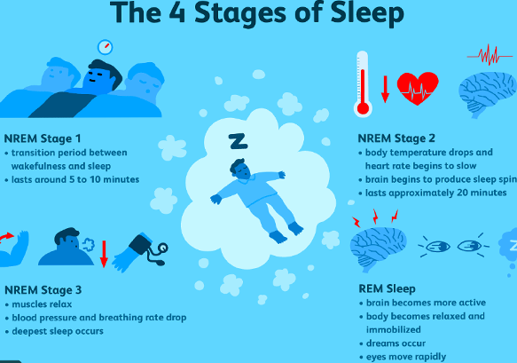

SLEEP CHART STAGE
 | Stage 1 - falling asleep | Stage 2 - light sleep | Stage 3 - deep sleep | REM SLEEP
Duration | several minutes, 5% | Spend more of your repeated sleep cycles in stage 2 than in other stages, 45% | longer periods during the first half of the night, 25% | Gets longer after each cycle, 25%
Body movements | Heartbeat, breathing, & eye movements slow, & muscles relax with occasional twitches | Heartbeat & breathing slow, & muscles relax even further, body temperature 🔽 & eye movements stop | Heartbeat & breathing slow to their 🔽 levels during sleep, muscles are relaxed and it may be difficult to awaken you | Eyes move rapidly behind closed lids, breath rate increases + body becomes temporarily paralyzed during dream (stop from hurting ourselves)
Brain waves (produced by large networks of neurons firing in synchronicity) | Brain waves begin to slow | Brain wave activity slows but is marked by brief bursts of electrical activity | Brain waves become even slower, strong | Brain waves are similar to those during wakefulness
Importance | Transitory stage from awake —> asleep | Brain organizing memories and information from the time you spent awake, filter out sensory information | Learning and memory, most restful and restorative, repair injuries and reinforce your immune system, metabolic regulation, hormone release | Memory consolidation, learning, and creativity

REM SLEEP (more info):
- Hippocampus: strengthens memories by replaying the day’s experiences, processing, categorising them before moving them into long-term memory
- Amygdala: processes emotional memories, tagging feelings, prioritising them for storage
- Emotions are more likely to be processed apart from factual content, and so less likely to be filtered
  - By replaying emotional moments while dreaming, we’re able to experience them with less intensity, so we can deal with them in a more balanced way.

Cycle 🔁 ~4-5 times, 90 to 120 minutes each:
- stage 2 NREM sleep: each one is longer than the last
- Each time more REM, less deep sleep

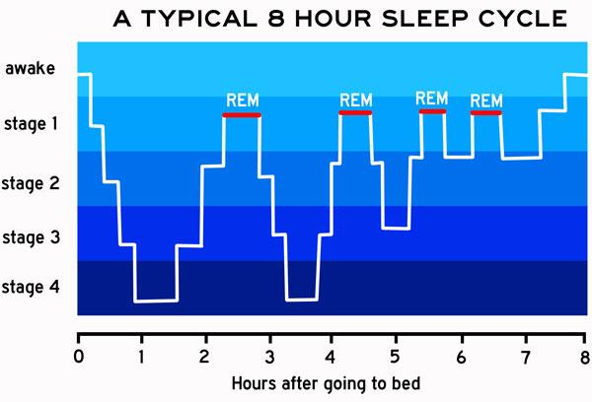

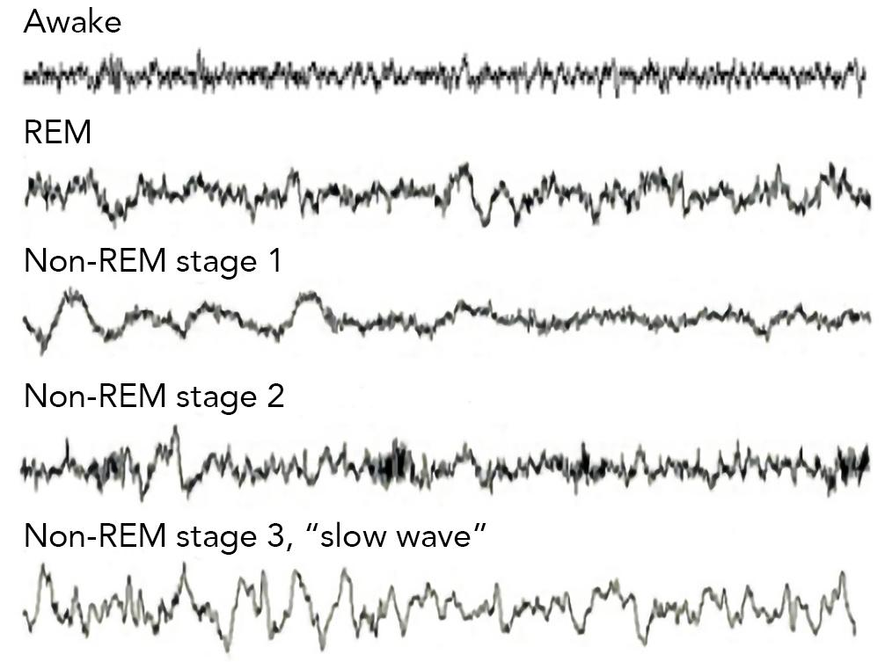

WAVES:
Non-REM sleep:
- Amplitude: ⬆️
- Frequency: Slow
- Small chunks of experience are replayed at high speed
REM sleep (brought by 📈 of brain chemical acetylcholine in brain’s outer surface)
- Amplitude: ⬇️ (higher than wakefulness)
- Frequency: Fast (slower than wakefulness)
- Alpha rhythm
- Memories are replayed in real-time and sensations like motion are rekindled

NEURONS:
- 📉 in the activation or "firing" rate of most neurons throughout the brain (wakefulness —> non-REM sleep)
- Wakefulness: random & variable activity pattern
- Non-REM sleep: coordinated & synchronous pattern
- REM sleep: random and variable (similar to wakefulness)
  - 📈 in the firing rate of most neurons throughout the brain, as compared to non-REM sleep

TEMPERATURE:
- Before we fall asleep: Lose some heat to the environment
  - Help induce sleep
- During sleep: Central set temperature is reduced by 1-2°F
  - Use less energy maintaining our body temperature
  - Conserve energy
- REM sleep: body temperature falls to lowest point

RESPIRATORY CHANGES:
- Awake: breathing is irregular
  - affected by speech, emotions, exercise, posture, etc.
- Wakefulness-stages of non-REM sleep: breathing rate slightly 📉 and becomes very regular
- REM sleep: breathing rate 📈 overall
  - Pattern becomes much more variable again

CARDIOVASCULAR ACTIVITY (Heart):
- Function of sleep: Give the heart a chance to rest from the constant demands of waking life
- Non-REM sleep: overall 📉 in heart rate & blood pressure
- REM sleep: overall 📈 in blood pressure & heart rate, variation in cardiovascular activity
  - Changes in blood flow:
    - Cause erections to occur in males/swelling of the clitoris in females

INCREASED PHYSIOLOGICAL ACTIVITY DURING SLEEP:.
- Overall, many physiological activities are reduced during sleep
  - Ex. Kidney function slows & production of urine 📉
- Some physiological processes may be maintained/even increased during sleep
  - Ex. 📈 in the release of growth hormone & physiological activities associated with digestion, cell repair, and growth are often greatest during sleep, suggesting that cell repair and growth may be an important function of sleep

Causes for sleep:
Sleep pressure:
- Inevitable accumulation of sleepiness each day
  - Caused by a gradual buildup of the molecule adenosine in 🧠
  - Adenosine is a byproduct of expending energy; it’s freed up from the energy-carrying molecule ATP, which fuels all living cells
Circadian rhythms:
- 24-hour biological 🕜 keeps time for your every cellular function, allowing your body to reliably anticipate and respond to its physiological needs (ex. sleep)
  - Proteins build up each night and degrade each day, and the whole system is reliant on environmental cues, most notably natural light

STAGE 2 NREM SLEEP:
Sleep spindle:
- brief, rhythmic bursts of brainwave activity (12-14 Hz) that appear as "spindle" shapes on an EEG during Stage 2 NREM sleep
- crucial for processing + consolidating memories, learning new skills, maintaining sleep stability
- plays a role in emotional regulation to recovery from stress
K-complexes:
- single, high-amplitude waves
- Can be triggered by external or internal stimuli & may help protect sleep and contribute to memory consolidation
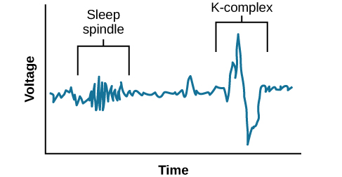

THALAMUS WTFFFFFFFF
- network of cell groups activate the thalamus & cerebral cortex
- key switch in the hypothalamus shuts off this arousal system during sleep
  - other hypothalamic neurons stabilize the switch (absence —> inappropriate switching of behavioural states —-> narcolepsy, insomnia, etc.)
- acts as a gatekeeper for sleep, blocking sensory information during NREM sleep while relaying it during REM sleep for dreams
- Crucial for regulating sleep cycles by controlling thalamo-cortical rhythms (ex. delta waves, sleep spindles)

